Analysis Document
NB: This is not the final Memo see Memo attached
Hope Tatenda Mutema
Data Set: Spotify Million Songs, file spotify_data.csv
Topic: Analyzing what makes song popular using the Spotify Million Songs data set.
Analytical Question: Are highly danceable or energetic tracks more popular and how these trends vary by genre and year.
Variables:
- danceability
- energy
- popularity
- genre
- duration (in milliseconds)
- year (the subsetting variable)
Data Analysis Process
- Data Collection
We have used the Spotify Million Songs data set provided in the project resources.
- Data Cleaning and Importation
See qmd attached.
- Danceability: Numeric Variable/ Double in R, it is a continuous ration (quantitative variable)
- Energy: Numeric variable/ Double in R, it is a continuous ration (quantitative variable)
- Popularity: Integer Variable in R, is a discrete ration (quantitative variable)
- Genre: Categorical data – Nominal variable, is a character variable in R. Total Number of genres – 82. There are no missing values in the genre column as depicted in the R qmd file
- Year, Categorical data, Ordinal, recoded it to be an ordered factor
- Duration in milliseconds, it is a ration Integer variable in R
Subsetting / recoding data for analysis
We randomly selected 1000 observations from the data set and set.seed(126) has been set for reproducibility.
Selected variables (columns) of choice and 1000 rows(observations) and created a new object for analysis.

After Recoding in R
- Danceability – numeric
- Energy – numeric
- Popularity – integer
- Genre – Character
- Year – ordinal factor
- duration_ms - Integer
Subsetting data to only analyze data from 2021-2023
Univariate Analysis
We are analyzing the general distribution of song popularity (Variable of Interest) in our dataset to see were most song ranges in terms of popularity.
Popularity – Shows the tracks popularity on a scale of 0-100
Table 2: Summary Statistics for the song popularity
N | Min | 1st Qtr | Median | Mean | 3rd Qtr | Max | SD
204 | 0.00 | 14.75 | 29.00 | 28.52 | 41.00 | 72.00 | 17.49

Using the descr from summarytools package, For the calculation of sd and N see qmd attached. Below is the R output for the summary statistics not in PQ see memo for PQ tables
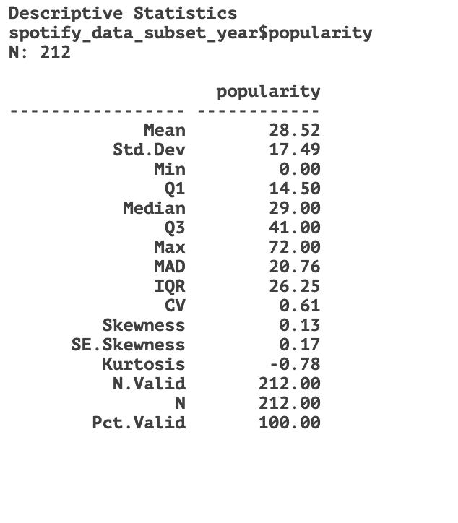
The popularity is broadly spread with the median slightly above the mean.
Distribution and Popularity: the median is 29 while the mean is 28.52 which shows that the average is being pulled by a small group of popular songs. popularity of songs range from a minimum of 0 to a maximum of 72.00, indicating that while some songs find little to no audience, others achieve high engagement standard deviation in 17.49, which is large relative to the mean, reflecting significant variation among songs. the inter quartile range is from 14.50 to 41.00 (IQR) shows that half of the songs cluster in the lower third of the possible popularity scale, so big hits are relatively rare. A small positive skewness means there are a modest number of tracks with the higher popularity extending the right tail, but the distribution is close to symmetrical, it is shown by a value of 0.13 on the summary stats in R
Using a Box plot to show the spread of the data
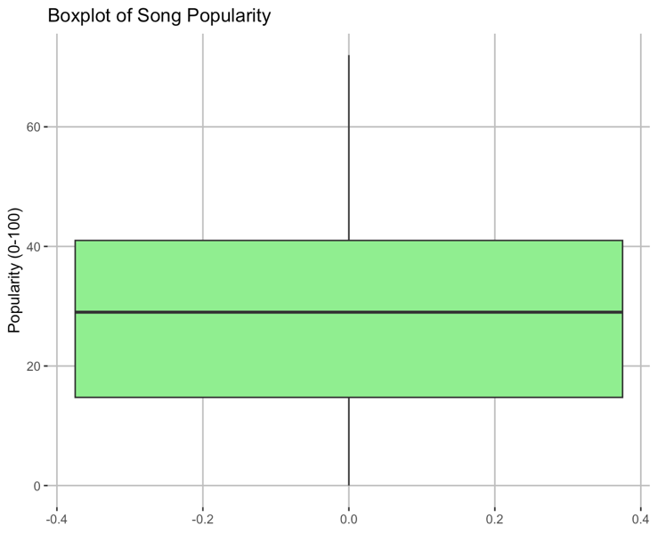
Histogram Showing the distribution of the song popularity
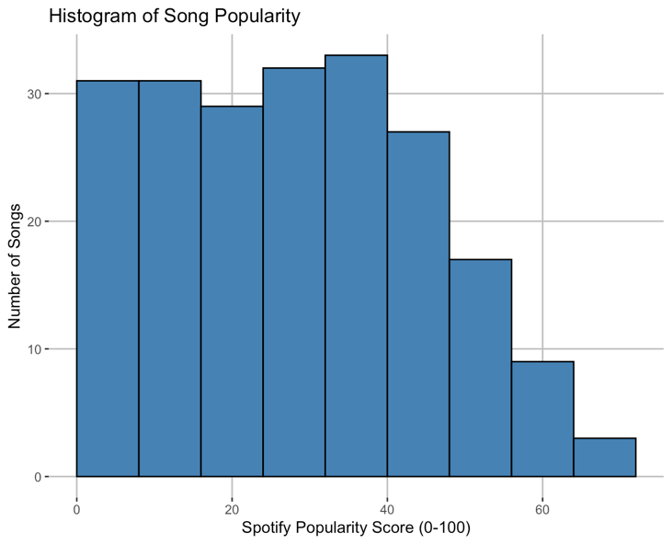

For Bivariate Analysis minimum of 6
- Popularity Vs Danceability
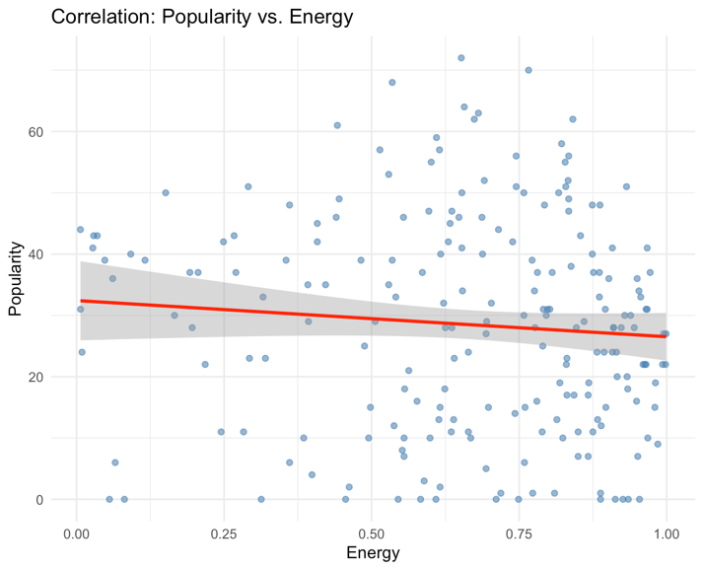
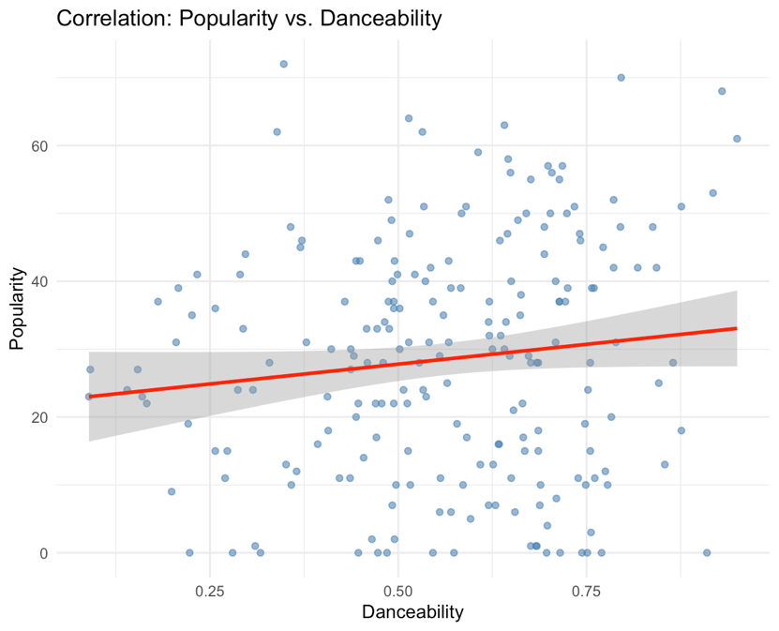
Analyzing the correlation between danceability and popularity using the scatter plot by fitting a regression line which shows a slight upward slope, this suggests that songs with higher danceability tend to be a bit more popular, although the effect isn’t very strong. The points are widely scattered around the line, which indicates a weak correlation, while the general trend is positive, many songs with low danceability are still popular and on the other hand many songs with high danceability are not very popular. Popularity ranges mostly between 0 and 60, with few songs going higher and danceability is spread across the whole range (0 to 1) showing that both low and high danceability songs exists at all popularity levels. Conclusion, Danceability is not the main factor driving popularity hence need to explore other features. However, the week positive relationship does suggest that more danceable songs may have a slight edge in becoming popular.
Relationship between Energy and Popularity: There is a week positive correlation between energy and popularity which indicates the need to explore other feature to see if there is a strong positive correlation with popularity. The popularity of the song is spread out from 10-60 regardless of energy levels. Therefore, energy on its own does not strongly predict popularity hence other factors such as lyrics, marketing or artist reputation probably have a bigger role in determining popularity. Relationship between Song Duration and Popularity
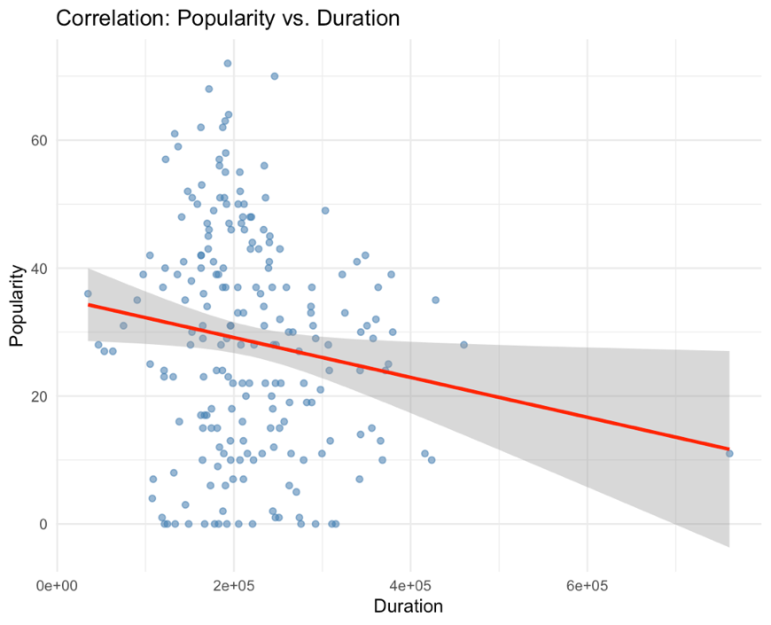
The regression line slopes slightly downward, showing a weak negative correlation between song duration and popularity. This means longer songs tend to be slightly less popular, though the spread of points is wide.Many popular songs still fall within shorter durations, but overall duration has a very little effect on popularity compared to other features like danceability or energy.
Overall Conclusion
None of the three features (danceability, energy, duration) strongly determines popularity on their own.Danceability and energy show slight positive relationship, while duration has a slight negative effect.Popularity is likely influenced by a combination of multiple factors (such as lyrics, artist reputation, marketing, and genre) rather than any single audio feature.
Trend Analysis, of music popularity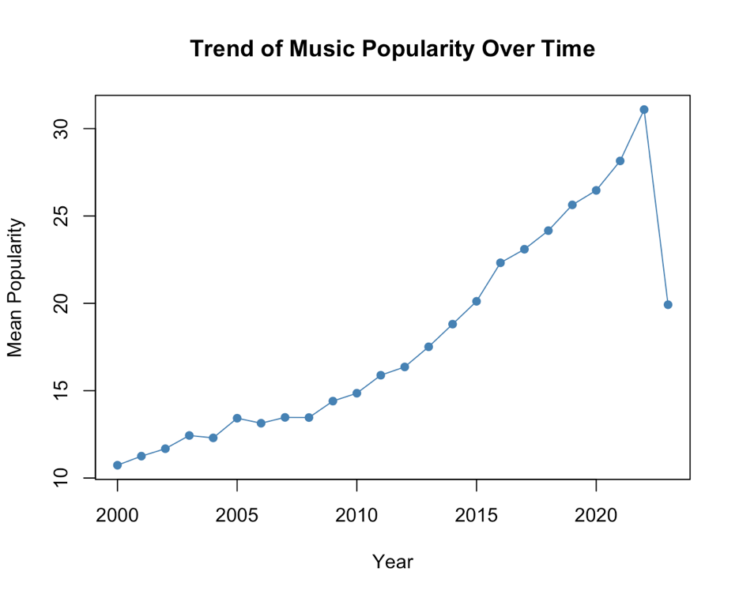 over time

The trend is showing a gradual increase in trends popularity for the last 20 years that is from 2000 to 2020. The market saturation has been realized between 2020 and 2023, and popularity suddenly dropped, a greater factor being the ease with which artist can now distribute music independently, so more music has been flooding the industry, poor quality music and good quality music hence dragging down the numbers of the average to as low as 19.92 among other factors. Despite a sudden drop in popularity, basing on the last two decades trends, popularity is likely to be on an upward gradual trend in the next decade holding other factors constant.
Danceability trend
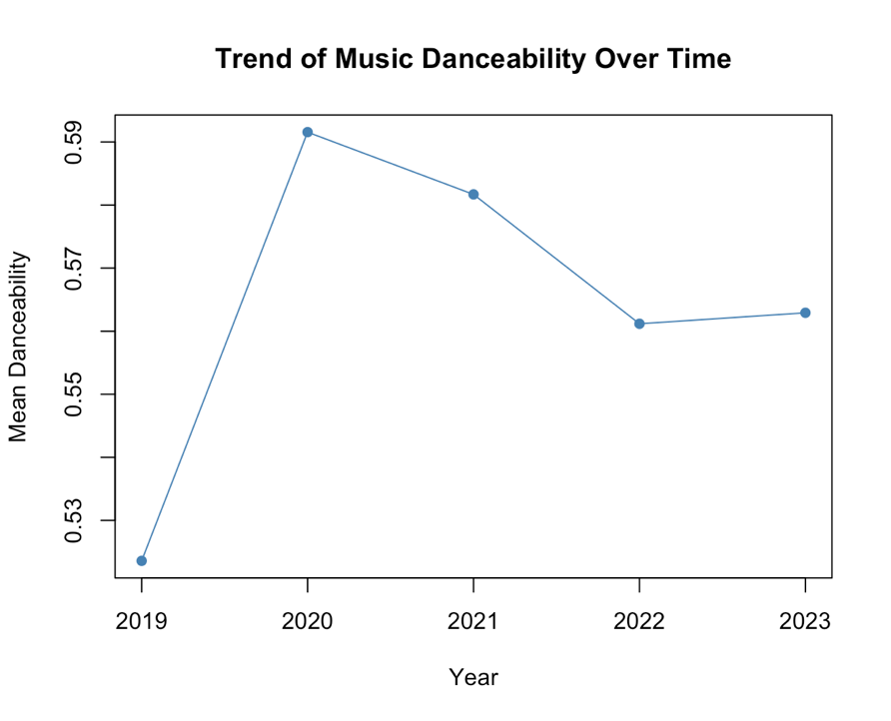
From the above danceability trend line, it is evident that most songs range in the same danceability levels from 0.50 to 0.60 over a period of 5 years, which reflect that most songs are danceable.There is a gradual decrease in the danceability of songs in the music industry. Relationship of genre and year Used R to find how many songs per genre were released each year and found out during period from 2000 to 2023, comedy genre was the most distributed songs.
Trivariate Analysis
See the R code in QMD file
- by summarizing the three we reveal actionable insights that bivariate analysis miss
- we will be able to see how different levels of danceability affects popularity over time
- First divide the song danceability into either High or Low using the median (we opted to use the median for splitting the group since the data is not symmetrical (normally distributed)
- We calculated the average mean popularity per each group every year
See R output below not a PQ table
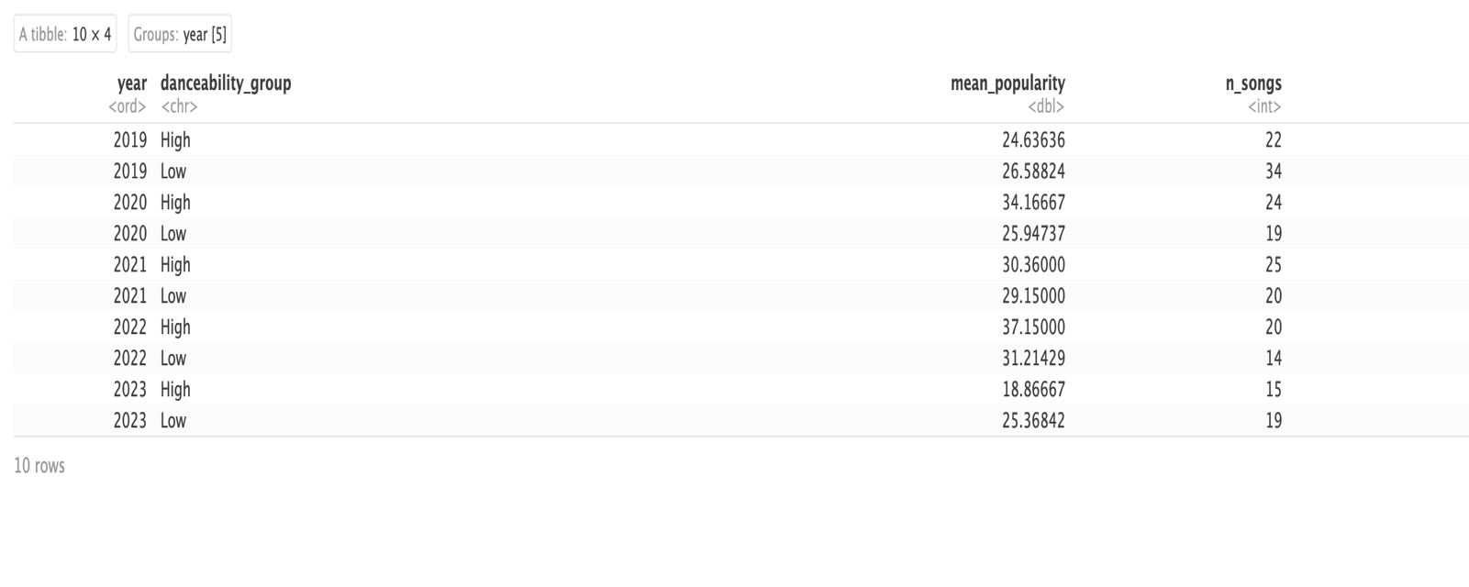
Trivariate Visualization
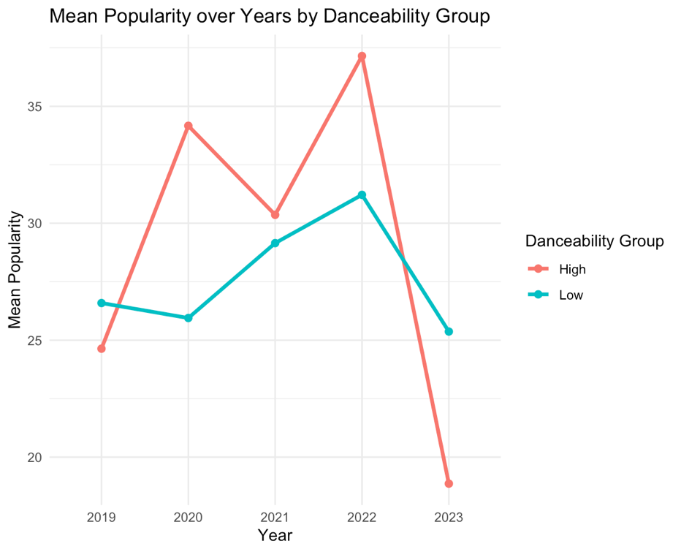

- From the above trivariate graph we can conclude that music with high danceability mostly dominate the ones with low danceability in terms of popularity even though there is a weak correlation between danceability and popularity as depicted by the bivariate statistics.

